**Before you start**

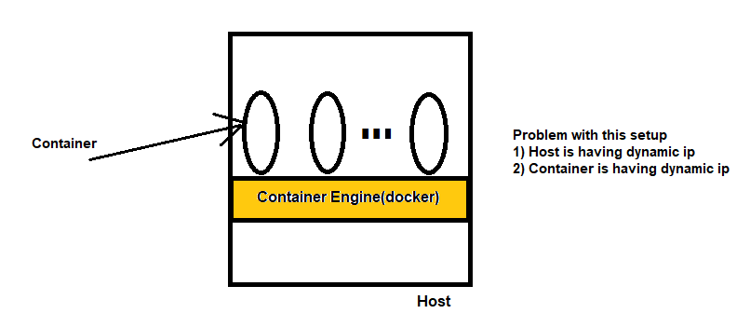

Solution 1: Assign static ip to host, and access container by using port forwarding. Command: docker run -p 8080:8080 ngnix.

Above approach is having issue, because amazon will charge you for providing static ip.(what is your host is more then 100).

To overcome this problem, we decided to user load balancing mechanism.

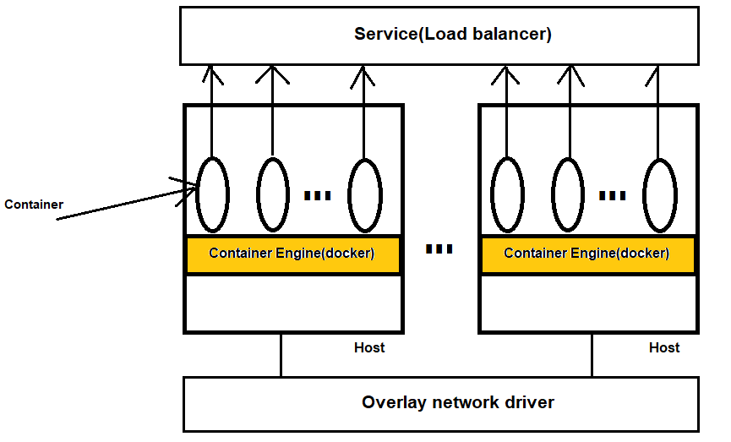

Now, I have 3 way to access the docker container:

1) By direct hit, 2) by Node name, 3) By using service IP.

Above diagram indicate clustering setup, and I can have multiple similar setups within my organisation, let me give name of this setup is microservices setup of Application.

In Real time environment, we will have multiple similar setups, and those can we managed by cluster ip.

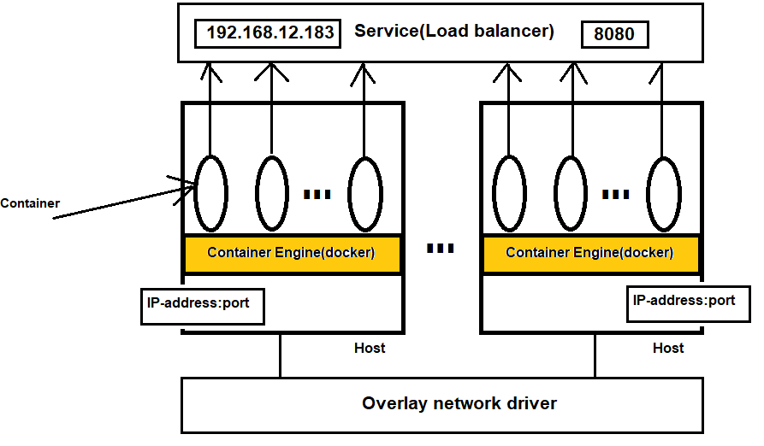

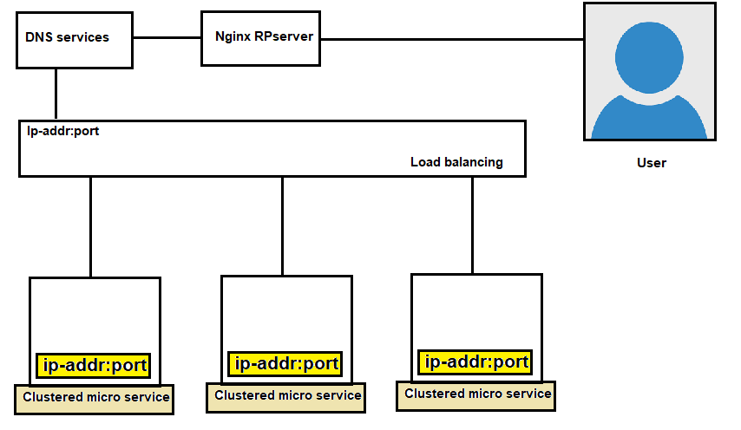

Above Diagram represent ingress network where we can implement security.

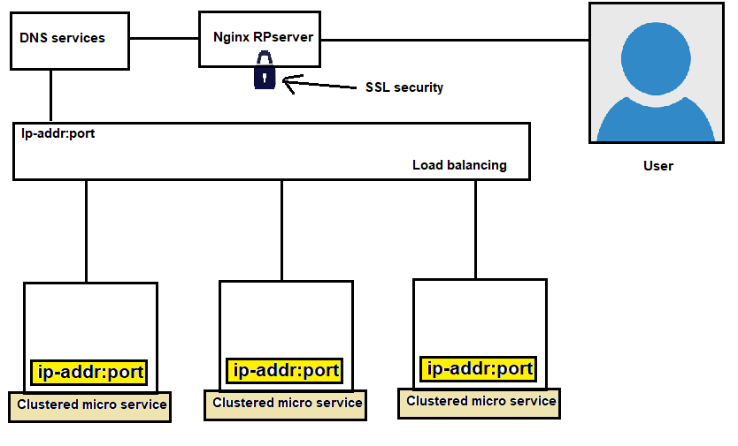

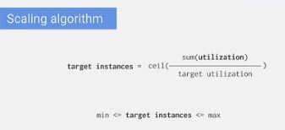

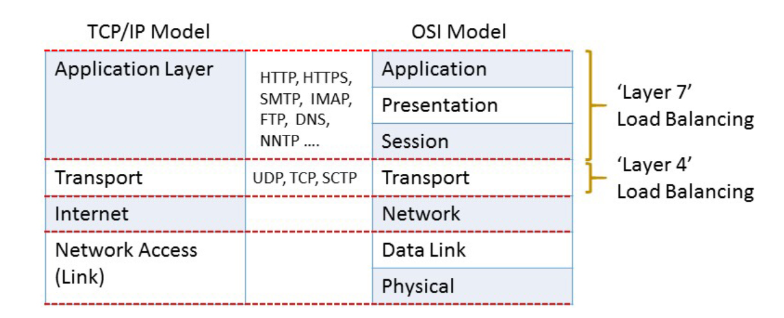

**Service Discovery**

* So far, we have learnt how to create Pods, Deployments and other controllers which help in deploying the containerized applications.
* We also have learnt each pod gets IP address.
* How can we connect to the applications running in the pods from external and also with in cluster.
* To help with this we have Kubernetes services. Services allows us to make logical set of pods discoverable and accessible for other pods running inside the cluster or to the external world

**Kubernetes Services**

* Basic workflow 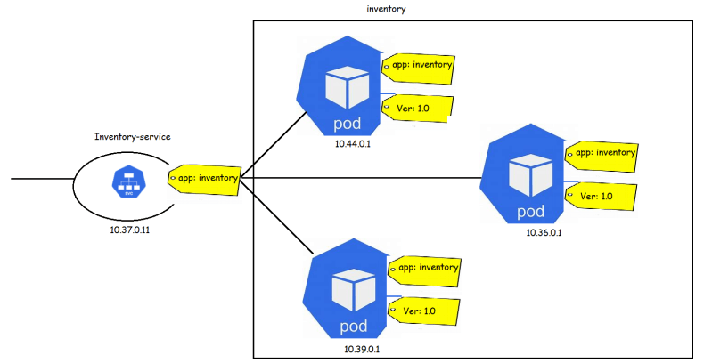

Types of Services

* + NodePort: This type of services makes internal pods accessible on the port of the node on which pods are running
  + ClusterIp: This type of service exposes the Service on a certain ip address within cluster
  + LoadBalancer: This type of Services exposes application externally using the load balancer provided by cloud provider
  + ExternalName: This type of service points to a DNS rather than set of pods

**Service :** An abstract way to expose an application running on a set of [Pods](https://kubernetes.io/docs/concepts/workloads/pods/) as a network service.

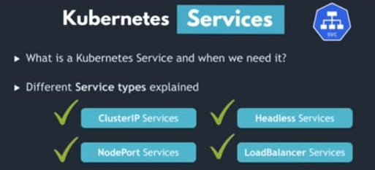

With Kubernetes you don't need to modify your application to use an unfamiliar service discovery mechanism. Kubernetes gives Pods their own IP addresses and a single DNS name for a set of Pods and can load-balance across them.

Example: ClusterIP, Nodeport, loadbalance and headless.

**Motivation**

Kubernetes [Pods](https://kubernetes.io/docs/concepts/workloads/pods/) are created and destroyed to match the state of your cluster. Pods are no permanent resources. If you use a [Deployment](https://kubernetes.io/docs/concepts/workloads/controllers/deployment/) to run your app, it can create and destroy Pods dynamically.

Each Pod gets its own IP address, however in a Deployment, the set of Pods running in one moment in time could be different from the set of Pods running that application a moment later.

This leads to a problem: if some set of Pods (call them "backends") provides functionality to other Pods (call them "frontends") inside your cluster, how do the frontends find out and keep track of which IP address to connect to, so that the frontend can use the backend part of the workload?

**Service resources**

In Kubernetes, a Service is an abstraction which defines a logical set of Pods and a policy by which to access them (sometimes this pattern is called a micro-service). The set of Pods targeted by a Service is usually determined by a [selector](https://kubernetes.io/docs/concepts/overview/working-with-objects/labels/). To learn about other ways to define Service endpoints, see [Services *without* selectors](https://kubernetes.io/docs/concepts/services-networking/service/#services-without-selectors).

For example, consider a stateless image-processing backend which is running with 3 replicas. Those replicas are fungible frontends do not care which backend they use. While the actual Pods that compose the backend set may change, the frontend clients should not need to be aware of that, nor should they need to keep track of the set of backends themselves.

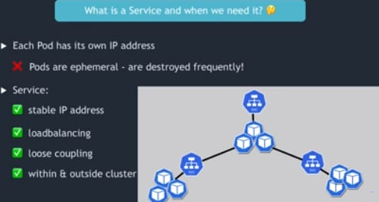

Cluster IP

In K8s, you may have multiple pods, and you can access them though direct IP, but those pods are ephemeral, so we assign a services to connect to those pods.

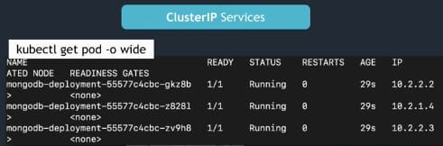

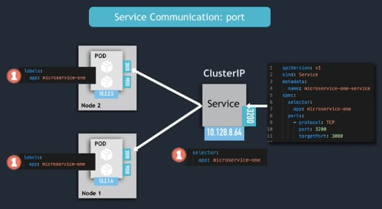

A Service in Kubernetes is a REST object, similar to a Pod. Like all of the REST objects, you can POST a Service definition to the API server to create a new instance. The name of a Service object must be a valid [DNS label name](https://kubernetes.io/docs/concepts/overview/working-with-objects/names#dns-label-names).

For example, suppose you have a set of Pods that each listen on TCP port 9376 and carry a label app=MyApp:

**apiVersion**: v1

**kind**: Service

**metadata**:

**name**: my-service

**spec**:

**selector**:

**app**: MyApp

**ports**:

- **protocol**: TCP

**port**: 80

**targetPort**: 9376

This specification creates a new Service object named "my-service", which targets TCP port 9376 on any Pod with the app=MyApp label.

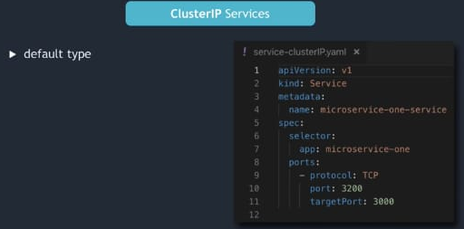

Multiport services: in Multiport container, we have one side car container, who gathers the logs for further RCA purpose.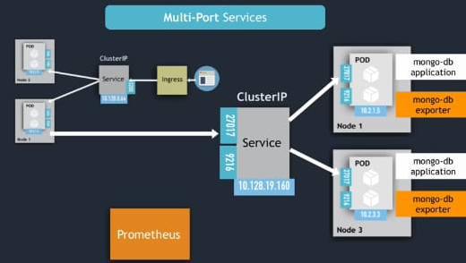

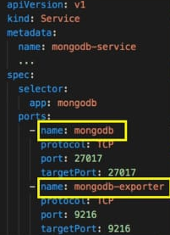

Headless services: it’s use for accessing stateful application.(ClusterIP= None)

A **Stateless** app is an application program that does not save client data generated in one session for use in the next session with that client.

A **Stateful** application saves data about each client session and uses that data the next time the client makes a request.

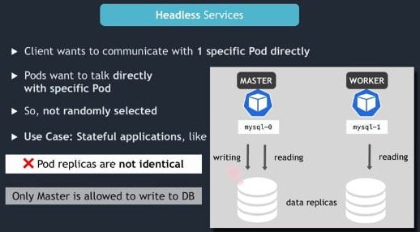

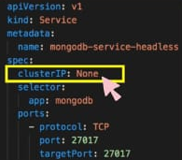

Nodeport services: it allows to access worker node by static port.

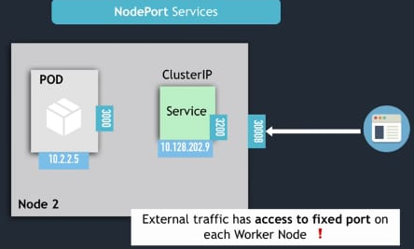

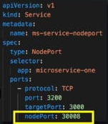

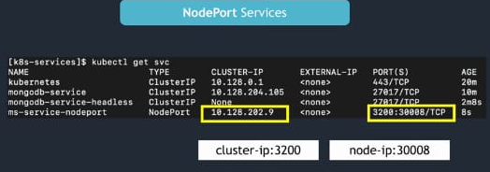

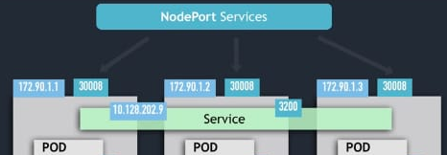

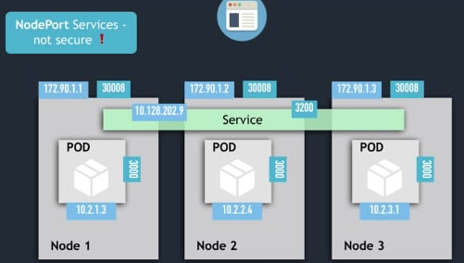

Load balancer service:

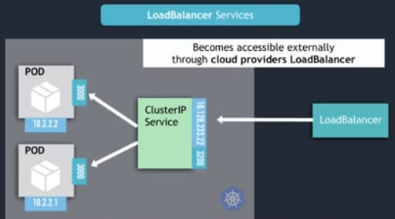

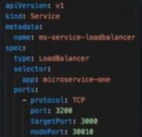

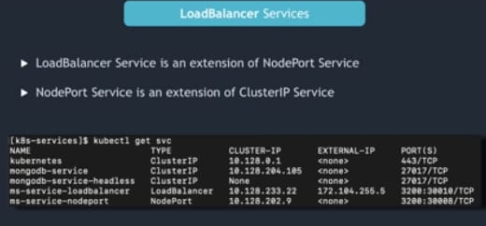

# Ephemeral Containers

a special type of container that runs temporarily in an existing [Pod](https://kubernetes.io/docs/concepts/workloads/pods/) to accomplish user-initiated actions such as troubleshooting. You use ephemeral containers to inspect services rather than to build applications.

Ingress Network

Suppose you are having online e-commerce store, and you have implemented to by Kubernetes.

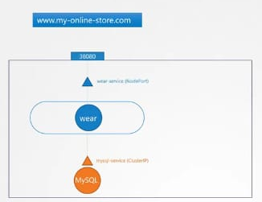

Here, you have used cluster-ip, node-port and DNS services. As you are using node port, so you can access that website by node-ip and port.

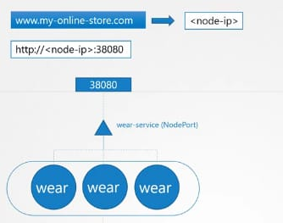

Now, your side is growing, and simultaneously you have launched multiple other products as well.

Here, by using cluster-ip, node-port and load balancer service, you can access your website outside, but still there are many more things such as SSL, and security thing.

DNS: The Domain Name System (DNS) is a [hierarchical](https://en.wikipedia.org/wiki/Hierarchy) and [decentralized](https://en.wikipedia.org/wiki/Decentralised_system) naming system for computers, services, or other resources connected to the [Internet](https://en.wikipedia.org/wiki/Internet) or a private network. It associates various information with [domain names](https://en.wikipedia.org/wiki/Domain_name) assigned to each of the participating entities. Most prominently, it translates more readily memorized domain names to the numerical [IP addresses](https://en.wikipedia.org/wiki/IP_address) needed for locating and identifying computer services and devices with the underlying [network protocols](https://en.wikipedia.org/wiki/Communication_protocol). By providing a worldwide, [distributed](https://en.wikipedia.org/wiki/Distributed_computing) [directory service](https://en.wikipedia.org/wiki/Directory_service), the Domain Name System has been an essential component of the functionality of the Internet since 1985.

/etc/hosts >> Here we add entry for host whom we want to communicate.

/etc/resolve.conf >> instead of adding multiple entry, let’s do it in centralized place.

During communication first it checks entry on /etc/hosts then /etc/resolve.conf

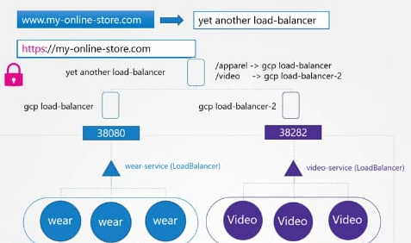

Instead of manual managing these things, we can opt ingress network concept.

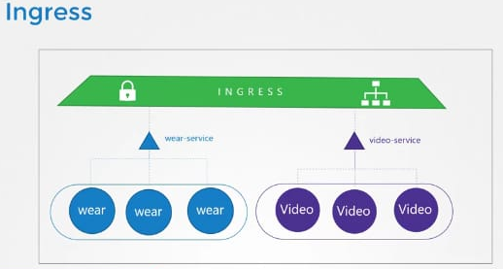

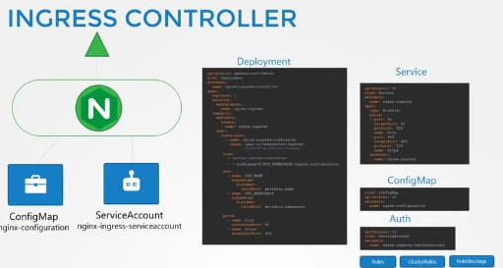

**FEATURE STATE:** Kubernetes v1.19

An API object that manages external access to the services in a cluster, typically HTTP.

Ingress may provide load balancing, SSL termination and name-based virtual hosting.

Terminology

For clarity, this guide defines the following terms:

* Node: A worker machine in Kubernetes, part of a cluster.
* Cluster: A set of Nodes that run containerized applications managed by Kubernetes. For this example, and in most common Kubernetes deployments, nodes in the cluster are not part of the public internet.
* Edge router: A router that enforces the firewall policy for your cluster. This could be a gateway managed by a cloud provider or a physical piece of hardware.
* Cluster network: A set of links, logical or physical, that facilitate communication within a cluster according to the Kubernetes [networking model](https://kubernetes.io/docs/concepts/cluster-administration/networking/).
* Service: A Kubernetes [Service](https://kubernetes.io/docs/concepts/services-networking/service/) that identifies a set of Pods using [label](https://kubernetes.io/docs/concepts/overview/working-with-objects/labels) selectors. Unless mentioned otherwise, Services are assumed to have virtual IPs only routable within the cluster network.

What is Ingress?

[Ingress](https://kubernetes.io/docs/reference/generated/kubernetes-api/v1.20/#ingress-v1-networking-k8s-io) exposes HTTP and HTTPS routes from outside the cluster to [services](https://kubernetes.io/docs/concepts/services-networking/service/) within the cluster. Traffic routing is controlled by rules defined on the Ingress resource.

Here is a simple example where an Ingress sends all its traffic to one Service:

cluster

Ingress-managed  
load balancer

routing rule

Ingress

Pod

Service

Pod

client

An Ingress may be configured to give Services externally-reachable URLs, load balance traffic, terminate SSL / TLS, and offer name-based virtual hosting. An [Ingress controller](https://kubernetes.io/docs/concepts/services-networking/ingress-controllers) is responsible for fulfilling the Ingress, usually with a load balancer, though it may also configure your edge router or additional frontends to help handle the traffic.

An Ingress does not expose arbitrary ports or protocols. Exposing services other than HTTP and HTTPS to the internet typically uses a service of type [Service.Type=NodePort](https://kubernetes.io/docs/concepts/services-networking/service/#nodeport) or [Service.Type=LoadBalancer](https://kubernetes.io/docs/concepts/services-networking/service/#loadbalancer).

Prerequisites

You must have an [Ingress controller](https://kubernetes.io/docs/concepts/services-networking/ingress-controllers) to satisfy an Ingress. Only creating an Ingress resource has no effect.

You may need to deploy an Ingress controller such as [ingress-nginx](https://kubernetes.github.io/ingress-nginx/deploy/). You can choose from a number of [Ingress controllers](https://kubernetes.io/docs/concepts/services-networking/ingress-controllers).

Ideally, all Ingress controllers should fit the reference specification. In reality, the various Ingress controllers operate slightly differently.

**Note:** Make sure you review your Ingress controller's documentation to understand the caveats of choosing it.

The Ingress resources

A minimal Ingress resource example: [**service/networking/minimal-ingress.yaml**](https://raw.githubusercontent.com/kubernetes/website/master/content/en/examples/service/networking/minimal-ingress.yaml)

**apiVersion**: networking.k8s.io/v1

**kind**: Ingress

**metadata**:

**name**: minimal ingress

**annotations**:

**nginx.ingress.kubernetes.io/rewrite-target**: /

**spec**:

**rules**:

- **http**:

**paths**:

- **path**: /testpath

**pathType**: Prefix

**backend**:

**service**:

**name**: test

**port**:

**number**: 80

As with all other Kubernetes resources, an Ingress needs apiversion, kind, and metadata fields. The name of an Ingress object must be a valid [DNS subdomain name](https://kubernetes.io/docs/concepts/overview/working-with-objects/names#dns-subdomain-names). For general information about working with config files, see [deploying applications](https://kubernetes.io/docs/tasks/run-application/run-stateless-application-deployment/), [configuring containers](https://kubernetes.io/docs/tasks/configure-pod-container/configure-pod-configmap/), [managing resources](https://kubernetes.io/docs/concepts/cluster-administration/manage-deployment/). Ingress frequently uses annotations to configure some options depending on the Ingress controller, an example of which is the [rewrite-target annotation](https://github.com/kubernetes/ingress-nginx/blob/master/docs/examples/rewrite/README.md). Different [Ingress controller](https://kubernetes.io/docs/concepts/services-networking/ingress-controllers) support different annotations. Review the documentation for your choice of Ingress controller to learn which annotations are supported.

The Ingress [spec](https://git.k8s.io/community/contributors/devel/sig-architecture/api-conventions.md#spec-and-status) has all the information needed to configure a load balancer or proxy server. Most importantly, it contains a list of rules matched against all incoming requests. Ingress resource only supports rules for directing HTTP(S) traffic.

Ingress rules

Each HTTP rule contains the following information:

* An optional host. In this example, no host is specified, so the rule applies to all inbound HTTP traffic through the IP address specified. If a host is provided (for example, foo.bar.com), the rules apply to that host.
* A list of paths (for example, /testpath), each of which has an associated backend defined with a service.name and a service.port.name or service.port.number. Both the host and path must match the content of an incoming request before the load balancer directs traffic to the referenced Service.
* A backend is a combination of Service and port names as described in the [Service doc](https://kubernetes.io/docs/concepts/services-networking/service/) or a [custom resource backend](https://kubernetes.io/docs/concepts/services-networking/ingress/#resource-backend) by way of a [CRD](https://kubernetes.io/docs/tasks/extend-kubernetes/custom-resources/custom-resource-definitions/). HTTP (and HTTPS) requests to the Ingress that matches the host and path of the rule are sent to the listed backend.

A defaultBackend is often configured in an Ingress controller to service any requests that do not match a path in the spec.

DefaultBackend

An Ingress with no rules sends all traffic to a single default backend. The default Backend is conventionally a configuration option of the [Ingress controller](https://kubernetes.io/docs/concepts/services-networking/ingress-controllers) and is not specified in your Ingress resources.

If none of the hosts or paths match the HTTP request in the Ingress objects, the traffic is routed to your default backend.

Resource backends

A Resource backend is an ObjectRef to another Kubernetes resource within the same namespace as the Ingress object. A Resource is a mutually exclusive setting with Service and will fail validation if both are specified. A common usage for a Resource backend is to ingress data to an object storage backend with static assets.